Manual Test Developer Andrés Restrepo Zapata  
API Rest Inventory

**INTRODUCTION**

This App is developed with the modules express, moment-timezone, morgan, sequelize, @babel/polyfill, pg pg hstore, Winston, jest, supertest.

The construction and initialization commands are available in the development and/or production environment thanks to @babel/polyfill.

* npm run build
* npm run dev
* npm run start

**LINK REPOSITORY GITHUB:** https://github.com/andresrestrepozapata21/inventary_test.git

For the purposes of this test, I send the endpoint URLs as if I were in a development environment, it is worth clarifying that everything is configured.

**DATABASE MER POSTGRES**

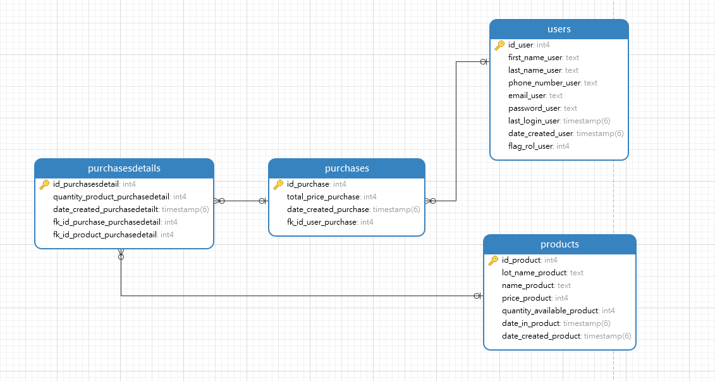

**ENDPOINTS**

Below are the instructions on how to consult each endpoint by making the call from a wizard, in this case postman, specifying the user's role and general information. The positive results of the endpoints are exposed but there is validation of errors.

* **User Register:**

**URL :** http://localhost:3000/api/users

**JSON REQ:**

{

    "first_name_user": "Diego",

    "last_name_user": "Arbelaez",

    "phone_number_user": "3133103302",

    "email_user": "diego@gmail.com",

    "password_user": "12345",

    "flag_rol_user": 1

}

**METHOD:** POST

**JSON RES:**

{

    "message": "User registed successfully",

    "data": {

        "id_user": 6,

        "first_name_user": "Diego",

        "last_name_user": "Arbelaez",

        "phone_number_user": "3133103302",

        "email_user": "diego@gmail.com",

        "password_user": "12345",

        "flag_rol_user": 1,

        "date_created_user": "2023-11-03T08:08:56.000Z",

        "last_login_user": **null**

    }

}

**-------------------------------------------------------------------------------------------------------------------------**

* **User Login:**

**URL :** http://localhost:3000/api/login

**JSON REQ:**

{

    "email_user": "andres@gmail.com",

    "password_user": "12345"

}

**METHOD:** POST

**JSON RES:**

{

    "message": "Successful login",

    "data": [

        {

            "id_user": 1,

            "email_user": "andres@gmail.com",

            "flag_rol_user": 2,

            "last_login_user": "2023-11-03T03:08:56.000Z"

        }

    ]

}

**MANAGER:**

* **Get All Users:**

**URL :** http://localhost:3000/api/users

**JSON REQ:**

Empty

**METHOD:** GET

**JSON RES:**

{

    "data": [

        {

            "id_user": 2,

            "first_name_user": "Carolina",

            "last_name_user": "Guillen",

            "phone_number_user": "3133103302",

            "email_user": "caro@gmail.com",

            "password_user": "12345",

            "last_login_user": **null**,

            "date_created_user": "2023-11-03T01:47:15.000Z",

            "flag_rol_user": 2

        },

        {

            "id_user": 3,

            "first_name_user": "Diego",

            "last_name_user": "Arbelaez",

            "phone_number_user": "3133103302",

            "email_user": "diego@gmail.com",

            "password_user": "12345",

            "last_login_user": **null**,

            "date_created_user": "2023-11-03T01:47:15.000Z",

            "flag_rol_user": 1

        },

…

**-------------------------------------------------------------------------------------------------------------------------**

* **Get All Products:**

**URL :** http://localhost:3000/api/purchases/all

**JSON REQ:**

Empty

**METHOD:** GET

**JSON RES:**

{

    "data": [

        {

            "id_product": 1,

            "lot_name_product": "lot 1",

            "name_product": "product 1",

            "price_product": 100,

            "quantity_available_product": 10,

            "date_in_product": "2023-11-02T19:09:09.000Z",

            "date_created_product": "2023-11-03T01:47:15.000Z"

        },

        {

            "id_product": 2,

            "lot_name_product": "lot 2",

            "name_product": "product 2",

            "price_product": 200,

            "quantity_available_product": 10,

            "date_in_product": "2023-11-02T19:09:09.000Z",

            "date_created_product": "2023-11-03T01:47:15.000Z"

        },

…

**-------------------------------------------------------------------------------------------------------------------------**

* **Get a Products:**

**URL :** http://localhost:3000/api/products/4

**JSON REQ:**

Empty

**METHOD:** GET

**JSON RES:**

{

    "data": {

        "id_product": 4,

        "lot_name_product": "lot 4",

        "name_product": "product 4",

        "price_product": 400,

        "quantity_available_product": 10,

        "date_in_product": "2023-11-02T19:09:09.000Z",

        "date_created_product": "2023-11-03T01:47:15.000Z"

    }

}

**-------------------------------------------------------------------------------------------------------------------------**

* **Get all pruchases:**

**URL :** http://localhost:3000/api/purchases/all

**JSON REQ:**

Empty

**METHOD:** GET

**JSON RES:**

{

    "data": [

        {

            "id_purchase": 2,

            "total_price_purchase": 800,

            "date_created_purchase": "2023-11-03T03:18:10.000Z",

            "user": {

                "id_user": 2,

                "first_name_user": "Carolina",

                "last_name_user": "Guillen",

                "phone_number_user": "3133103302",

                "email_user": "caro@gmail.com"

            },

            "purchasesdetails": [

                {

                    "id_purchasesdetail": 3,

                    "quantity_product_purchasedetail": 2,

                    "product": {

                        "id_product": 1,

                        "lot_name_product": "lot 1",

                        "name_product": "product 1",

                        "price_product": 100

                    }

                },

                {

                    "id_purchasesdetail": 4,

                    "quantity_product_purchasedetail": 3,

                    "product": {

                        "id_product": 2,

                        "lot_name_product": "lot 2",

                        "name_product": "product 2",

                        "price_product": 200

                    }

                }

            ]

        },

        {

            "id_purchase": 3,

            "total_price_purchase": 800,

            "date_created_purchase": "2023-11-03T03:18:10.000Z",

            "user": {

                "id_user": 1,

                "first_name_user": "Andres",

                "last_name_user": "Restrepo",

                "phone_number_user": "3186337855",

                "email_user": "andres@gmail.com"

            },

            "purchasesdetails": [

                {

                    "id_purchasesdetail": 5,

                    "quantity_product_purchasedetail": 2,

                    "product": {

                        "id_product": 1,

                        "lot_name_product": "lot 1",

                        "name_product": "product 1",

                        "price_product": 100

                    }

                },

                {

                    "id_purchasesdetail": 6,

                    "quantity_product_purchasedetail": 3,

                    "product": {

                        "id_product": 2,

                        "lot_name_product": "lot 2",

                        "name_product": "product 2",

                        "price_product": 200

                    }

                }

            ]

        },

        {

            "id_purchase": 1,

            "total_price_purchase": 800,

            "date_created_purchase": "2023-11-03T02:39:11.000Z",

            "user": {

                "id_user": 1,

                "first_name_user": "Andres",

                "last_name_user": "Restrepo",

                "phone_number_user": "3186337855",

                "email_user": "andres@gmail.com"

            },

            "purchasesdetails": [

                {

                    "id_purchasesdetail": 1,

                    "quantity_product_purchasedetail": 2,

                    "product": {

                        "id_product": 1,

                        "lot_name_product": "lot 1",

                        "name_product": "product 1",

                        "price_product": 100

                    }

                },

                {

                    "id_purchasesdetail": 2,

                    "quantity_product_purchasedetail": 3,

                    "product": {

                        "id_product": 2,

                        "lot_name_product": "lot 2",

                        "name_product": "product 2",

                        "price_product": 200

                    }

                }

            ]

        }

    ]

}

**-------------------------------------------------------------------------------------------------------------------------**

* **To record product:**

**URL :** http://localhost:3000/api/products

**JSON REQ:**

{

    "lot_name_product": "lot 6",

    "name_product": "product 6",

    "price_product": 600,

    "quantity_available_product": 10,

    "date_in_product": "2023-11-02 09:09:09"

}

**METHOD:** POST

**JSON RES:**

{

    "message": "Product registed successfully",

    "data": {

        "id_product": 7,

        "lot_name_product": "lot 6",

        "name_product": "product 6",

        "price_product": 600,

        "quantity_available_product": 10,

        "date_in_product": "2023-11-02T19:09:09.000Z",

        "date_created_product": "2023-11-03T08:08:56.000Z"

    }

}

**-------------------------------------------------------------------------------------------------------------------------**

* **To update product:**

**URL :** http://localhost:3000/api/products/1

**JSON REQ:**

{

    "lot_name_product": "lot",

    "name_product": "product",

    "price_product": 1,

    "quantity_available_product": 11,

    "date_in_product": "2023-10-03 10:09:09"

}

**METHOD:** PULL

**JSON RES:**

{

    "message": "Product updated successfully",

    "data": [

        {

            "id_product": 1,

            "lot_name_product": "lot",

            "name_product": "product",

            "price_product": 1,

            "quantity_available_product": 11,

            "date_in_product": "2023-10-03T15:09:09.000Z"

        }

    ]

}

**-------------------------------------------------------------------------------------------------------------------------**

* **To delete product:**

**URL :** http://localhost:3000/api/products/3

**JSON REQ:**

Empty

**METHOD:** DELETE

**JSON RES:**

{

    "message": "Product deleted successfully",

    "data": 1

}

**-------------------------------------------------------------------------------------------------------------------------**

**CUSTOMER:**

* **History purchases user:**

**URL :** http://localhost:3000/api/purchases/user/1

**JSON REQ:**

Empty

**METHOD:** GET

**JSON RES:**

{

    "data": [

        {

            "id_purchase": 3,

            "total_price_purchase": 800,

            "date_created_purchase": "2023-11-03T03:18:10.000Z",

            "purchasesdetails": [

                {

                    "id_purchasesdetail": 5,

                    "quantity_product_purchasedetail": 2,

                    "product": {

                        "id_product": 1,

                        "lot_name_product": "lot",

                        "name_product": "product",

                        "price_product": 1

                    }

                },

                {

                    "id_purchasesdetail": 6,

                    "quantity_product_purchasedetail": 3,

                    "product": {

                        "id_product": 2,

                        "lot_name_product": "lot 2",

                        "name_product": "product 2",

                        "price_product": 200

                    }

                }

            ]

        },

        {

            "id_purchase": 1,

            "total_price_purchase": 800,

            "date_created_purchase": "2023-11-03T02:39:11.000Z",

            "purchasesdetails": [

                {

                    "id_purchasesdetail": 1,

                    "quantity_product_purchasedetail": 2,

                    "product": {

                        "id_product": 1,

                        "lot_name_product": "lot",

                        "name_product": "product",

                        "price_product": 1

                    }

                },

                {

                    "id_purchasesdetail": 2,

                    "quantity_product_purchasedetail": 3,

                    "product": {

                        "id_product": 2,

                        "lot_name_product": "lot 2",

                        "name_product": "product 2",

                        "price_product": 200

                    }

                }

            ]

        }

    ]

}

**-------------------------------------------------------------------------------------------------------------------------**

* **Purchase Invoice:**

**URL :** http://localhost:3000/api/purchases/invoice/1

**JSON REQ:**

Empty

**METHOD:** GET

**JSON RES:**

{

    "data": [

        {

            "id_purchase": 1,

            "total_price_purchase": 800,

            "date_created_purchase": "2023-11-03T02:39:11.000Z",

            "user": {

                "id_user": 1,

                "first_name_user": "Andres",

                "last_name_user": "Restrepo",

                "phone_number_user": "3186337855",

                "email_user": "andres@gmail.com"

            },

            "purchasesdetails": [

                {

                    "id_purchasesdetail": 2,

                    "quantity_product_purchasedetail": 3,

                    "product": {

                        "id_product": 2,

                        "lot_name_product": "lot 2",

                        "name_product": "product 2",

                        "price_product": 200

                    }

                },

                {

                    "id_purchasesdetail": 1,

                    "quantity_product_purchasedetail": 2,

                    "product": {

                        "id_product": 1,

                        "lot_name_product": "lot",

                        "name_product": "product",

                        "price_product": 1

                    }

                }

            ]

        }

    ]

}

**-------------------------------------------------------------------------------------------------------------------------**

* **To record purchase:**

**URL :** http://localhost:3000/api/purchases

**JSON REQ:**

{

  "fk_id_user_purchase": 1,

  "total_price_purchase": 800,

  "products": [

    {

      "id_product": 1,

      "quantity_product": 2

    },

    {

      "id_product": 2,

      "quantity_product": 3

    }

  ]

}

**METHOD:** POST

**JSON RES:**

{

    "message": "Purchase registed successfully",

    "puchase": {

        "id_purchase": 4,

        "date_created_purchase": "2023-11-03T08:28:10.000Z",

        "total_price_purchase": 800,

        "fk_id_user_purchase": 1

    },

    "PurchaseDetail": [

        {

            "id_purchasesdetail": 7,

            "quantity_product_purchasedetail": 2,

            "date_created_purchasedetailt": "2023-11-03T08:28:10.000Z",

            "fk_id_purchase_purchasedetail": 4,

            "fk_id_product_purchasedetail": 1

        },

        {

            "id_purchasesdetail": 8,

            "quantity_product_purchasedetail": 3,

            "date_created_purchasedetailt": "2023-11-03T08:28:10.000Z",

            "fk_id_purchase_purchasedetail": 4,

            "fk_id_product_purchasedetail": 2

        }

    ]

}